You will be creating a website using HTML / JavaScript / CSS. The website will have the following:

• Home Page: Displaying a small intro about yourself.

• Projects: List all of your projects which can be filtered by typing technology (C# / Java / Node.js

etc.) in a textbox

• Education: Page which shows all the courses that you have studied in since 9th grade.

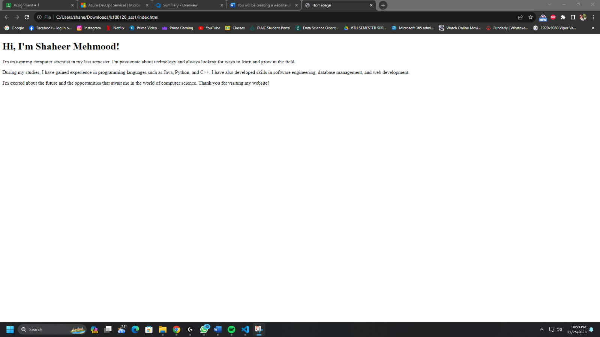

Task # 1:

Using Azure Boards with Scrum Process as your process model, create different work items (Features /

Product Backlog Item / Task) required for the mentioned scenario. You should fill in all the necessary

details as well as the duration for each Task. You will use Product Backlog for Activities which will be

broken into multiple tasks. Any Task which occupies more than 3 days should be spilt into multiple tasks.

[Note: You should have at least 15 tasks].

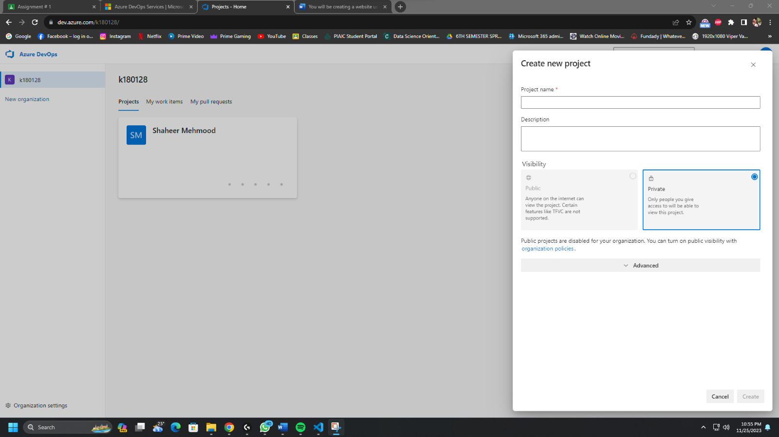

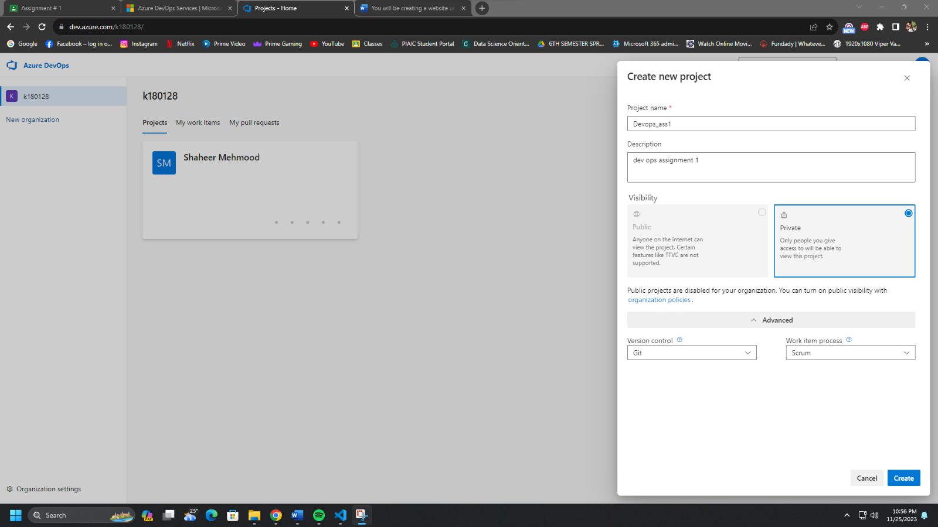

Created Task # 1:

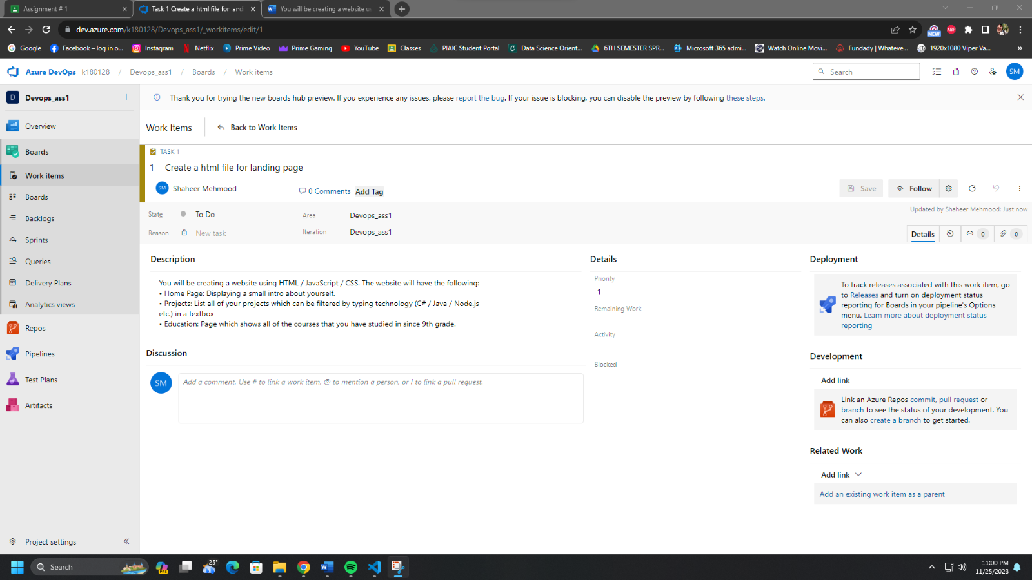

Created Task # 2:

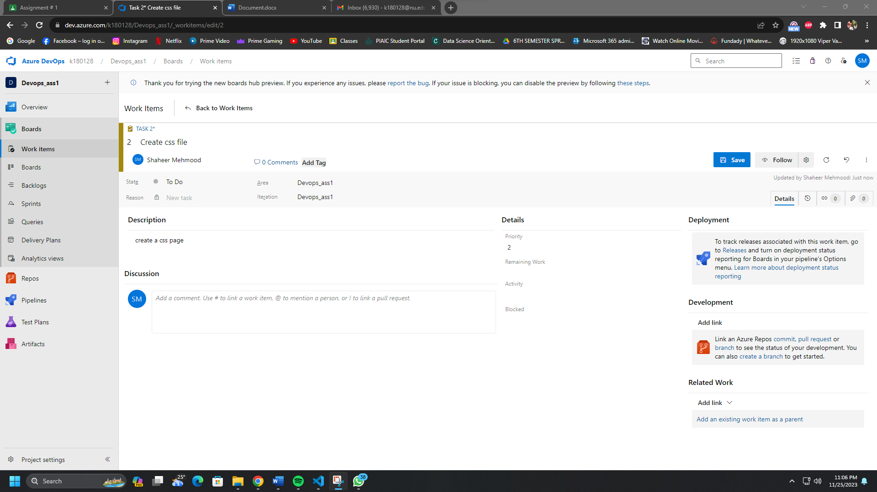

Linked with HTML File.

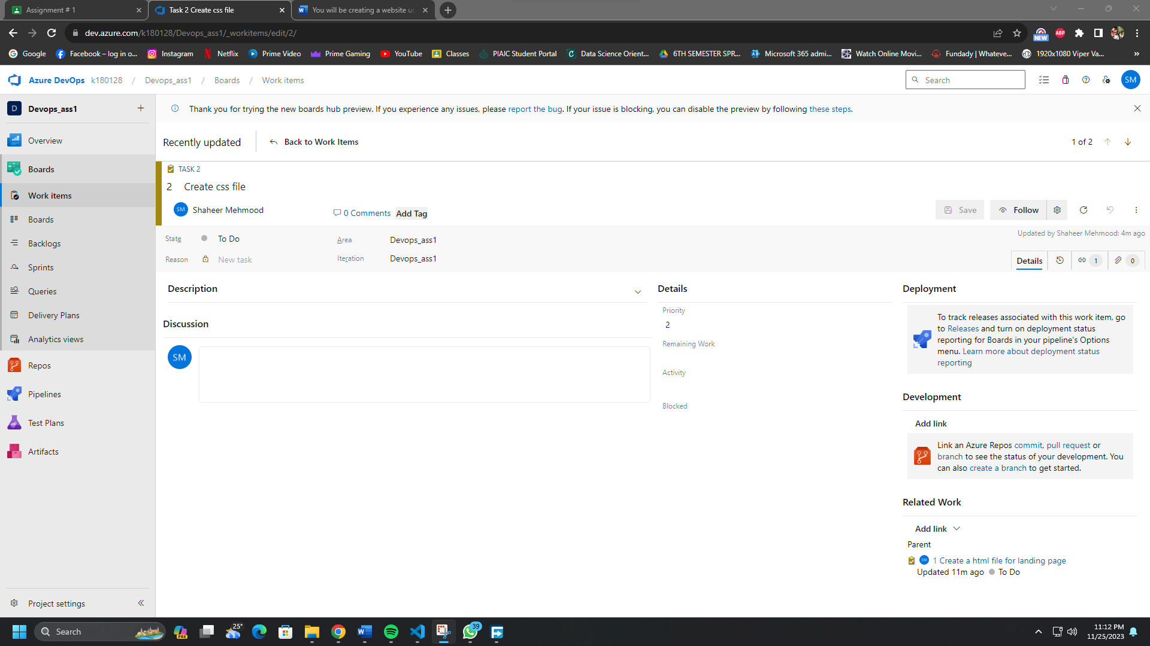

You will use Product Backlog for Activities which will be broken into multiple tasks.

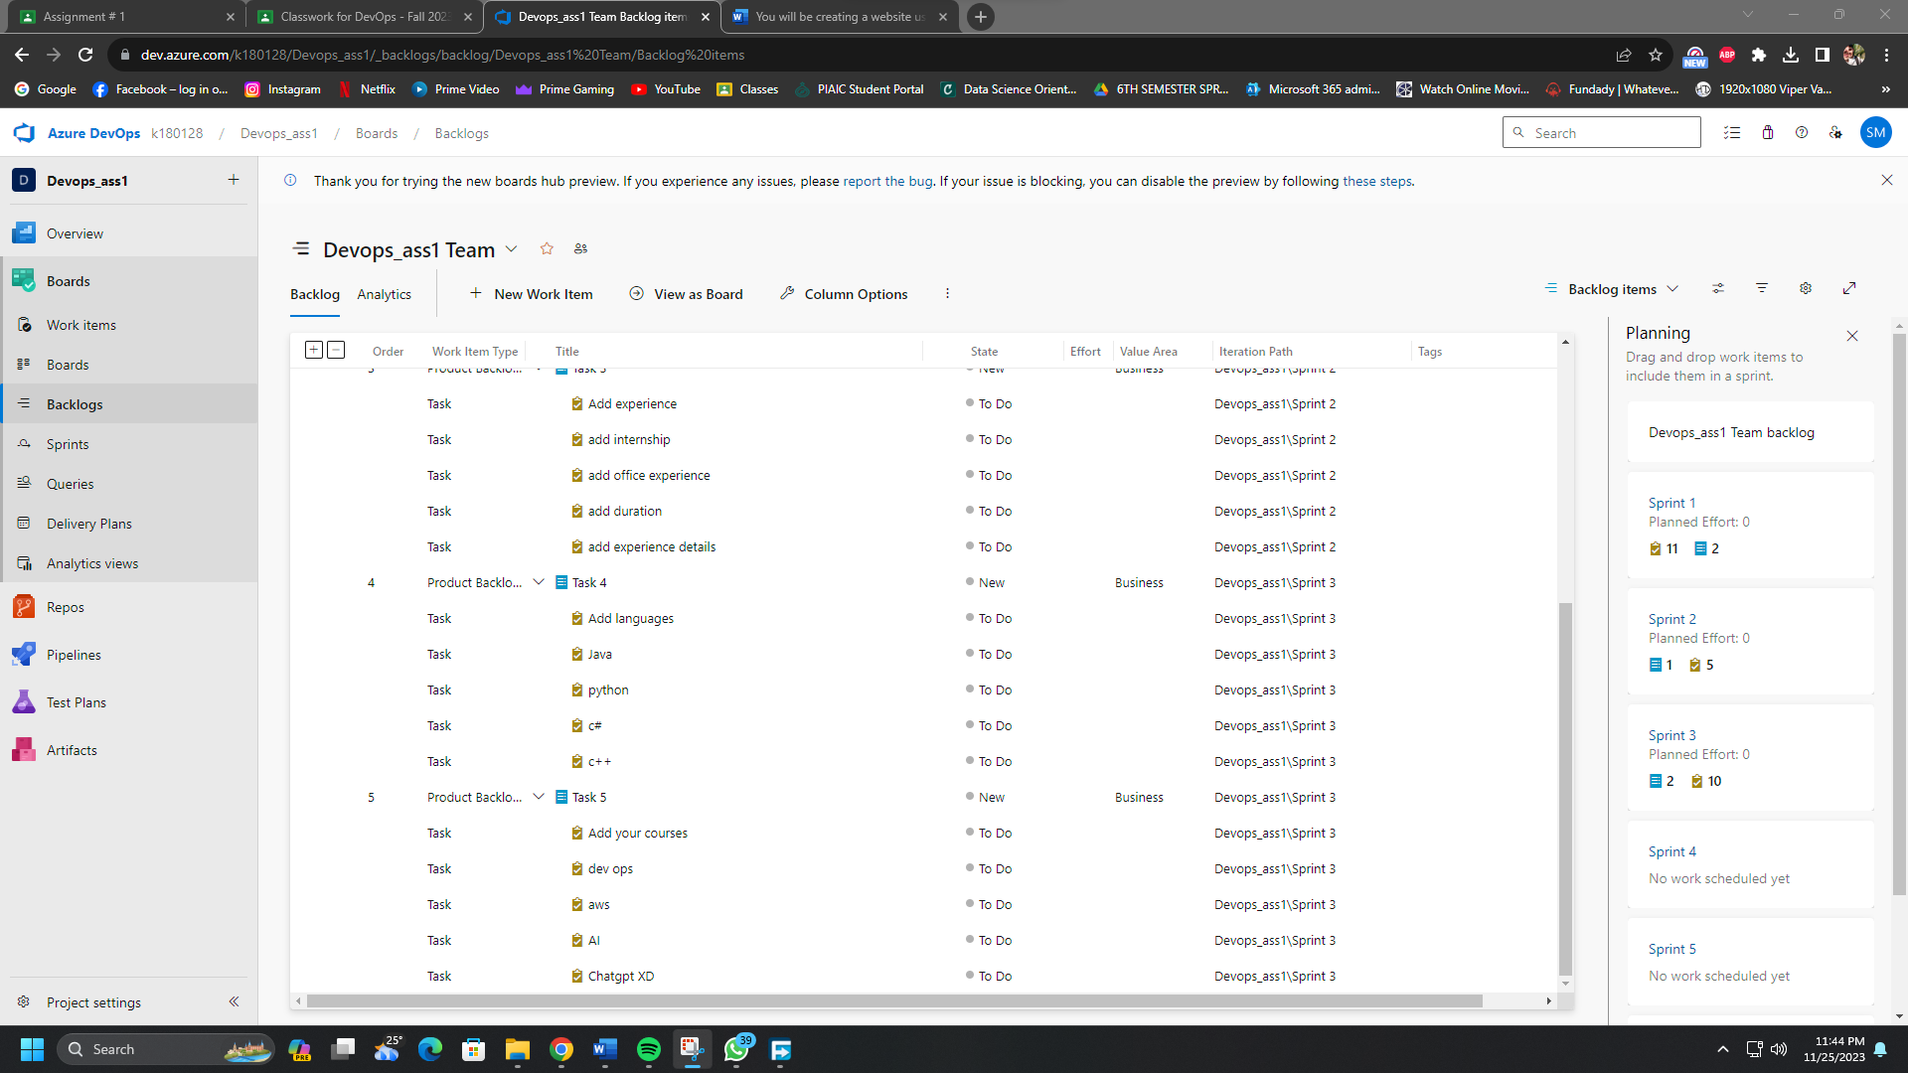

Task 2